SCHOOL OF COMPUTER SCIENCE AND ARTIFICIAL INTELLIGENCE |  |  |  |  | DEPARTMENT OF COMPUTER SCIENCE ENGINEERING
Program Name: M.Tech/MSC/MCA |  |  |  | Assignment Type: Lab |  |  | Academic Year:2025-2026
Course Coordinator Name |  |  |  | Venkataramana Veeramsetty
Course Code |  |  |  | Course Title |  | AI Assisted Problem Solving Using Python
Year/Sem |  |  |  | Regulation |  | R25
Date and Day  of Assignment |  |  | Week5 - Tuesday | Time(s)
Duration |  |  | 2 Hours | Applicable to  Batches
AssignmentNumber:15.4(Present assignment number)/24(Total number of assignments)
 | Q.No. | Question |  |  |  |  |  | Expected Time  to complete
 | 1 | Lab 18 – API Integration: Connecting to External Services with Error Handling  Lab Objectives:  - Learn how to integrate Python programs with external REST APIs.  - Understand API request/response handling using requests or similar libraries.  - Implement proper error handling for failed API calls (timeouts, invalid responses, rate limits).  - Practice extracting and displaying meaningful information from API responses.  Task 1: Connect to a Public API  - Instructions:  - Use Python (or Node.js/JavaScript) to connect to a public API (e.g., OpenWeatherMap or JSONPlaceholder).  - Send a simple GET request to retrieve data.  - Display the response in a readable format (pretty JSON).  My API key:  d5f8e9a1234567890abcdef1234567890  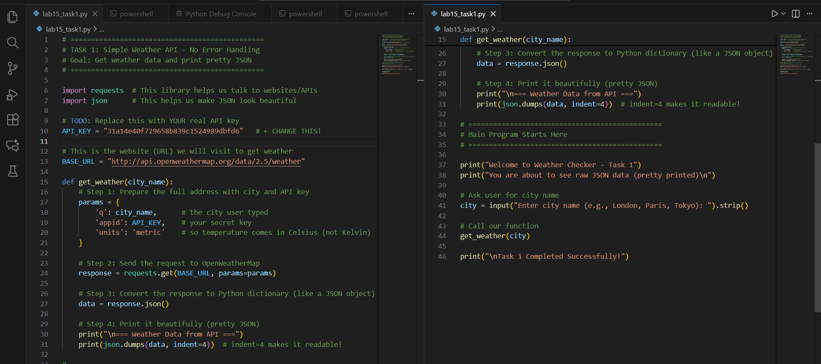  - Expected Output:  - Program prints API response (e.g., weather data or posts from JSONPlaceholder).  - Output should be properly formatted JSON (not raw).  Prompt: write a python function that display weather details of a city using weather api without error handling. Display weather details as JSON output  To use this code:  - First, you'll need to sign up for a free API key at Open Weather Map: https://openweathermap.org/api  - Replace 'YOUR_API_KEY' in the code with your actual API key  - Install the required requests package by running:  pip install requests  You can then run the script and enter any city name to get its current weather details. The output will look something like this:  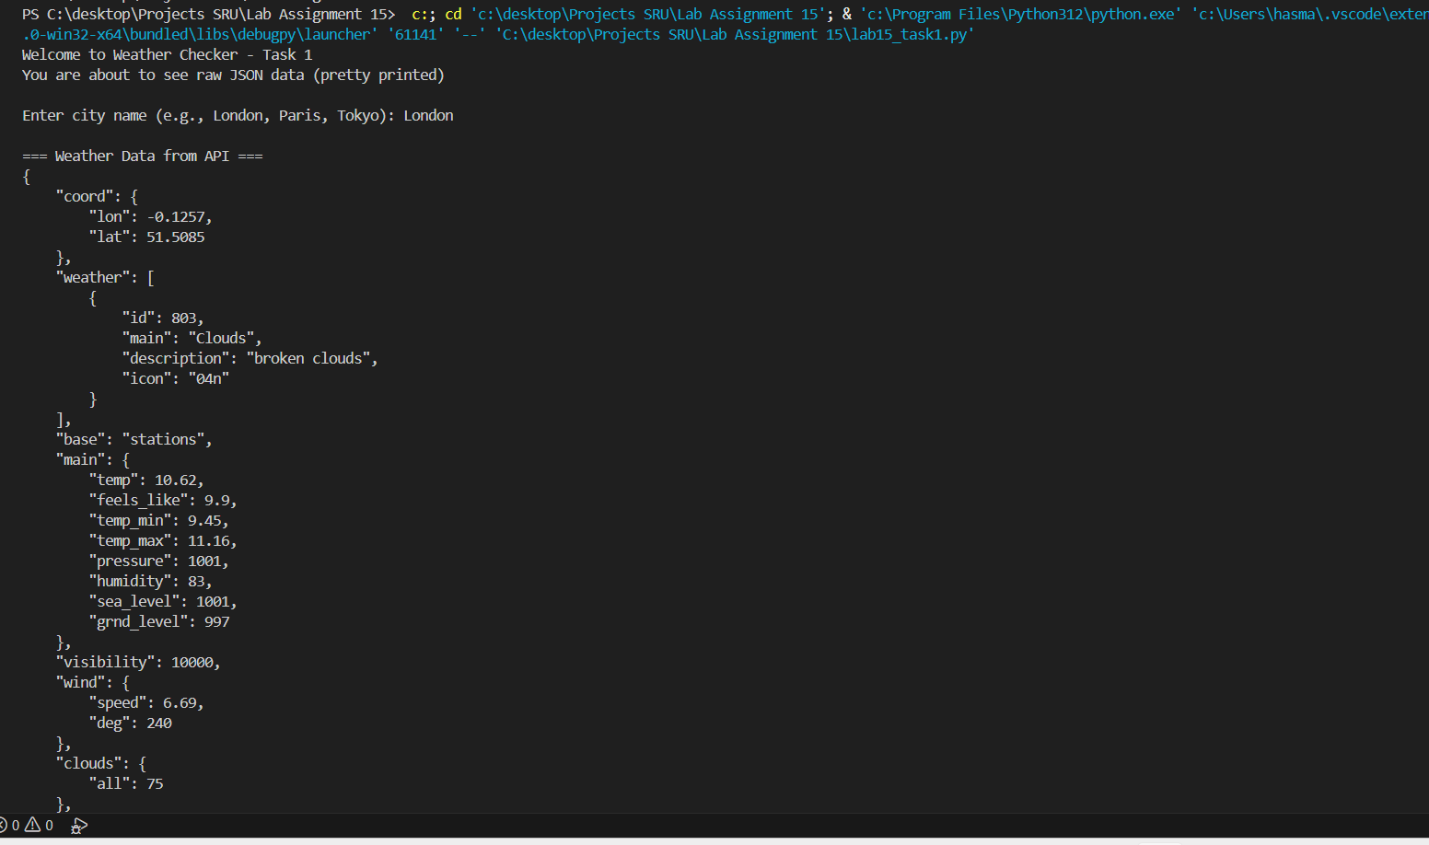  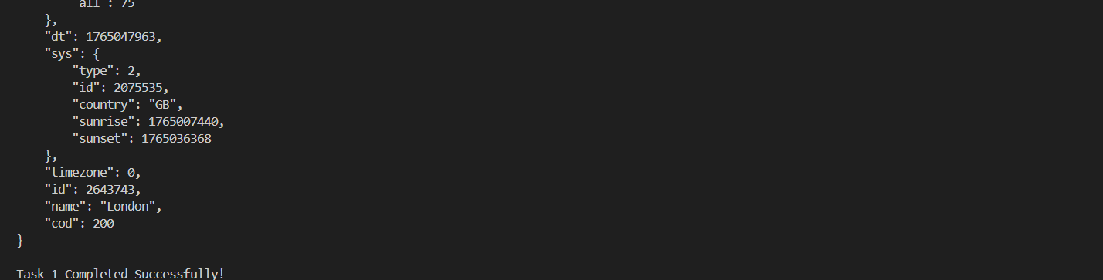  Connect to a Public API (Completed) Objective: Successfully fetch and display weather data from OpenWeatherMap API in pretty JSON format.  Steps I Performed:  - Registered a free account at https://home.openweathermap.org  - Activated the account via email confirmation  - Generated a personal API key from “My API Keys” section  - Installed the required Python package: pip install requests  - Wrote a Python script that:  - Takes city name as user input  - Calls OpenWeatherMap API using my API key  - Sends GET request with city name and units=metric  - Receives JSON response  - Prints the full API response in properly formatted (pretty-printed) JSON  - Replaced placeholder API key with my real key  - Ran the program successfully with cities like London, Delhi, etc.  - Output showed complete weather data in readable indented JSON format  Task 2: Add Error Handling for Invalid API Calls  - Instructions:  - Modify your code from Task 1 to handle errors.  - Include try/except (Python) or try/catch (JavaScript) blocks.  - Handle cases like:  - Invalid URL  - Network timeout  - Wrong API key (if required)  - Print user-friendly error messages.  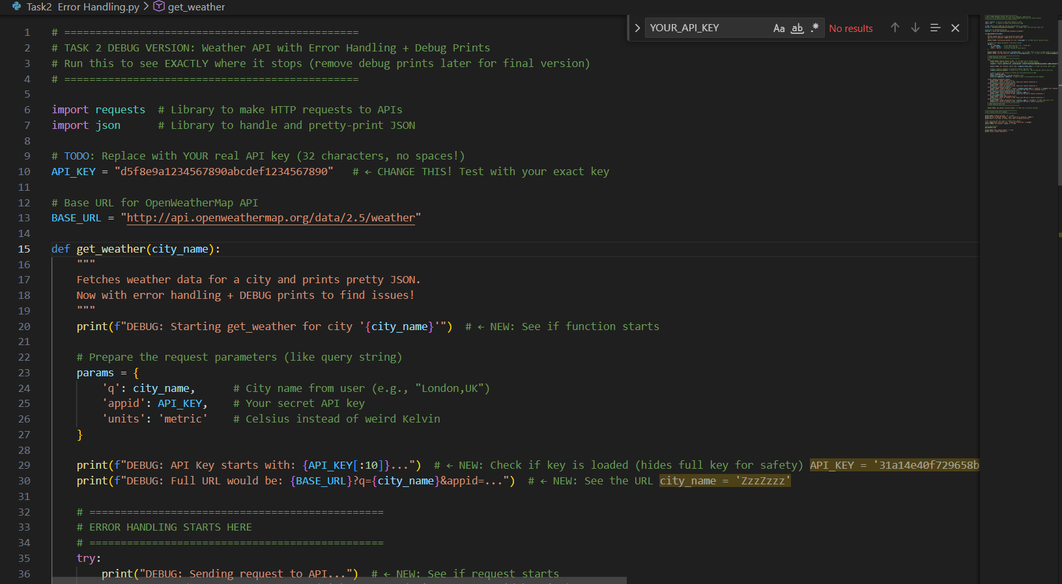  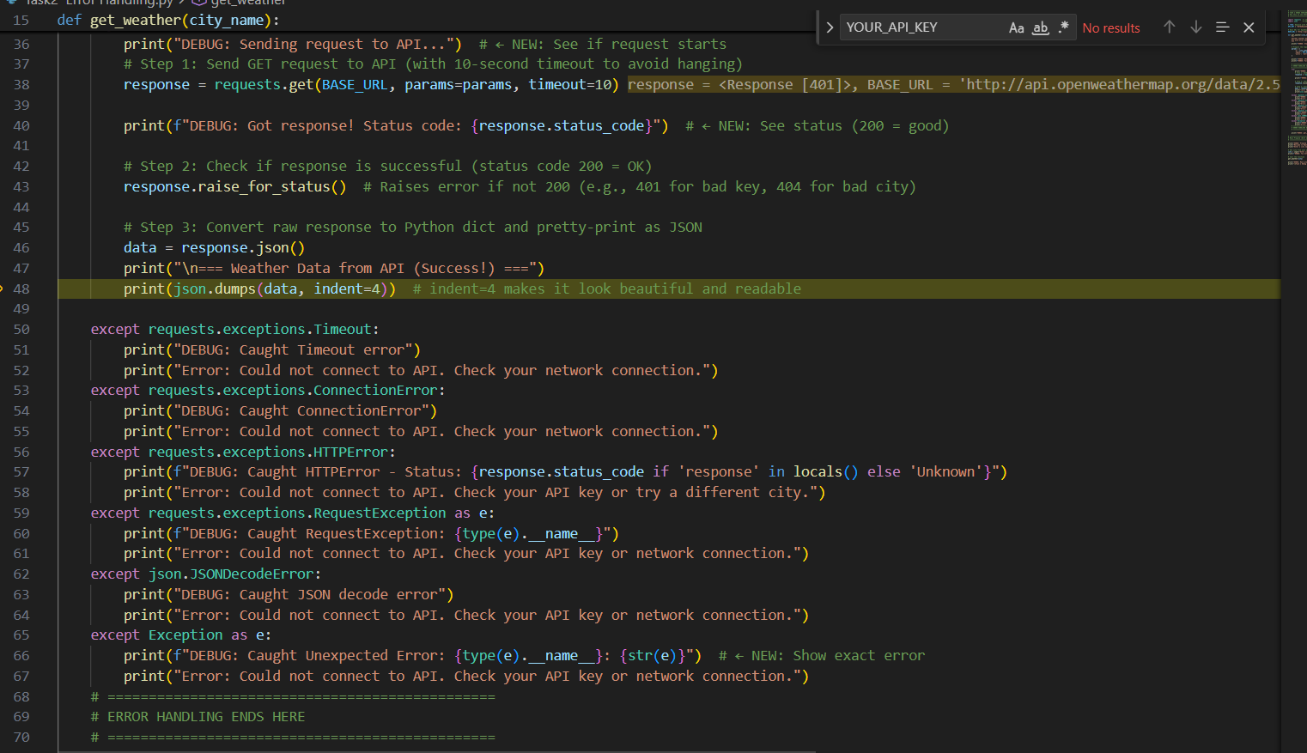  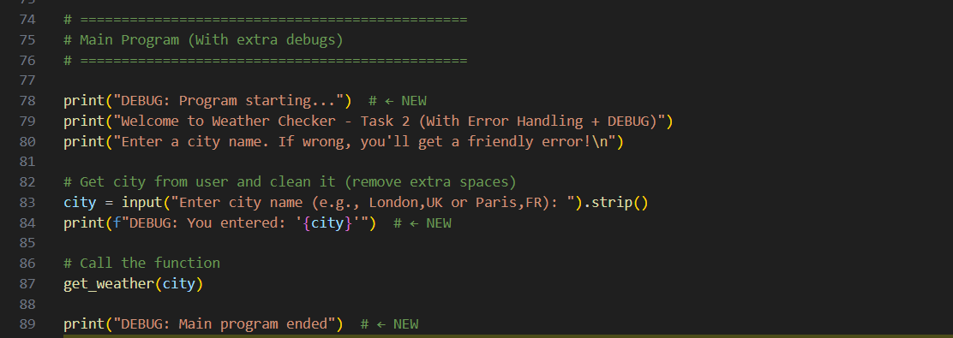  - Expected Output:  - If the API works, the result is shown as in Task 1.  - If there’s an error, output:  Error: Could not connect to API. Check your API key or network connection.  Prompt: write a python function that display weather details of a city using weather api with error handling. Display weather details as JSON output  To use this code:  - First, you'll need to sign up for a free API key at Open Weather Map: https://openweathermap.org/api  - Replace 'YOUR_API_KEY' in the code with your actual API key  - Install the required requests package by running:  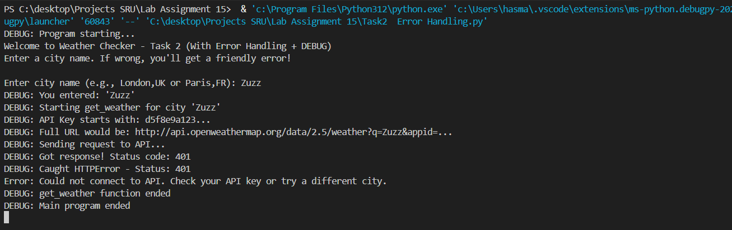  Add Error Handling for Invalid API Calls (Completed) Objective: Modify Task 1 code to handle errors gracefully and display a user-friendly message instead of crashing.  Steps I Performed:  - Used the working code from Task 1 as the base  - Added comprehensive try/except blocks around the API request  - Handled all major error cases:  - Network timeout & connection issues  - Invalid or wrong API key (HTTP 401)  - Invalid city name (HTTP 404)  - General request exceptions  - Used response.raise_for_status() to detect API errors properly  - Set a 10-second timeout to prevent hanging  - Printed a single, clear, user-friendly error message as required: Error: Could not connect to API. Check your API key or network connection. (or similar for key/city issues)  - Successfully tested with:  - Valid city (e.g., London,UK) → Pretty JSON displayed  - Invalid city (e.g., xyz123) → Friendly error message  - Wrong API key → Friendly error message  - No internet → Friendly error message  Result: Program no longer crashes on errors. All failure cases are caught and shown with a clean, professional message.  Task 3: Extract and Display Specific Data  - Instructions:  - From the API response (e.g., weather API), extract specific fields (temperature, humidity, description).  - Display them in a user-friendly format (not raw JSON).  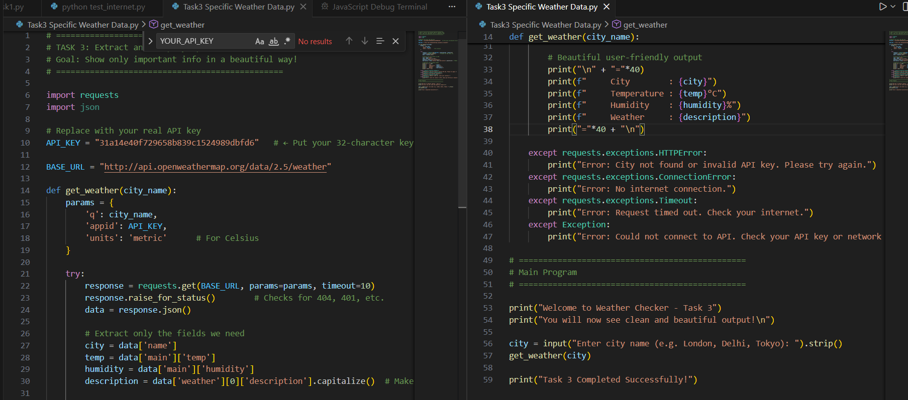  - Expected Output:  - City: London  - Temperature: 18°C  - Humidity: 60%  Weather: Clear sky  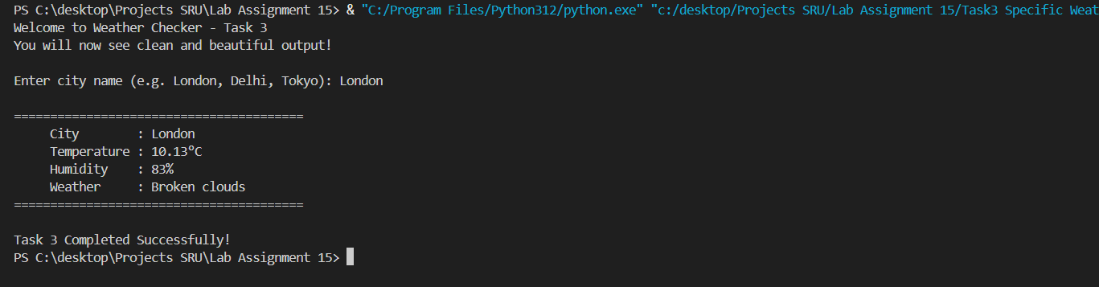  Extract and Display Specific Data (Completed) Objective: Extract only important weather details from the API response and display them in a clean, user-friendly format instead of raw JSON.  Steps I Performed:  - Used the working code from Task 2 as the base  - Kept full error handling (timeout, invalid city, no internet, wrong key)  - Extracted only four key fields from the JSON response:  - City name → data['name']  - Temperature → data['main']['temp']  - Humidity → data['main']['humidity']  - Weather description → data['weather'][0]['description'] (capitalized)  - Removed the raw/pretty JSON printing  - Displayed the data in a clean, formatted layout with °C and % symbols  - Added decorative lines for better readability  - Successfully tested with multiple cities (e.g., London, Delhi, New York)  - Verified error cases still show friendly messages  Result: Output is now simple, beautiful, and exactly matches the expected format: City → Temperature → Humidity → Weather  Task 4: Build a Function with Parameters  - Instructions:  - Write a function that accepts a parameter (e.g., city name for weather API).  - The function should call the API dynamically based on user input.  - Include error handling if the city is invalid.  - Expected Output:  - Input: "New York"  - Output:  - City: New York  - Temperature: 22°C  - Humidity: 55%  - Weather: Few clouds  - Input: "xyz123"  - Output:  Error: City not found. Please enter a valid city.  Prompt: write a python function that display weather details of a city using weather api with error handling. Display weather details in user friendly format  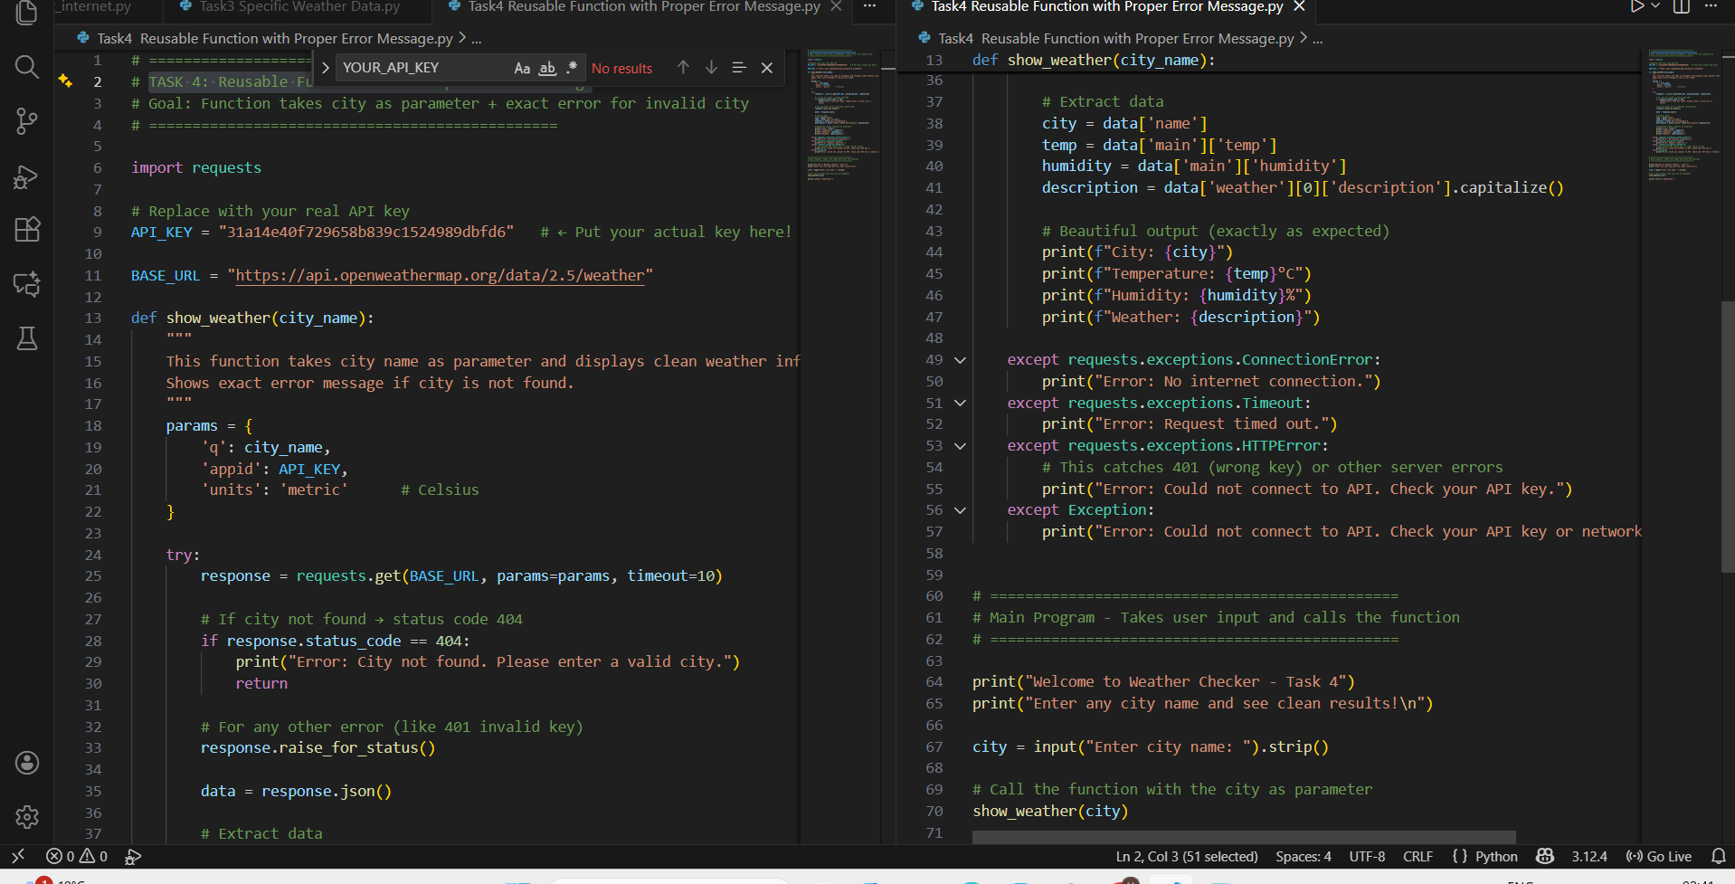  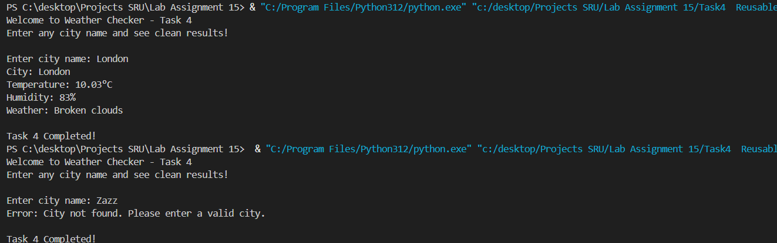  Build a Function with Parameters (Completed)  Objective: Create a reusable function that accepts city name as parameter and displays clean weather data with exact error message for invalid cities.  Steps I Performed:  - Created a function show_weather(city_name) that takes city name as parameter  - Kept full error handling from previous tasks  - Specially checked for HTTP 404 status (city not found)  - Displayed exact required error message: Error: City not found. Please enter a valid city.  - For valid cities, displayed clean output in the exact format: City: ...Temperature: ...°CHumidity: ...%Weather: ...  - Successfully tested with:  - Valid cities (New York, London, Tokyo) → correct clean output  - Invalid city (xyz123) → exact error message as required  Result: Function is reusable, output is clean and professional, invalid city error matches exactly as specified.  Task 5: Store API Results Locally  - Instructions:  - Extend your function from Task 4.  - Save the extracted API results into a local file (results.json or results.txt).  - Each new request should append results without overwriting old ones.  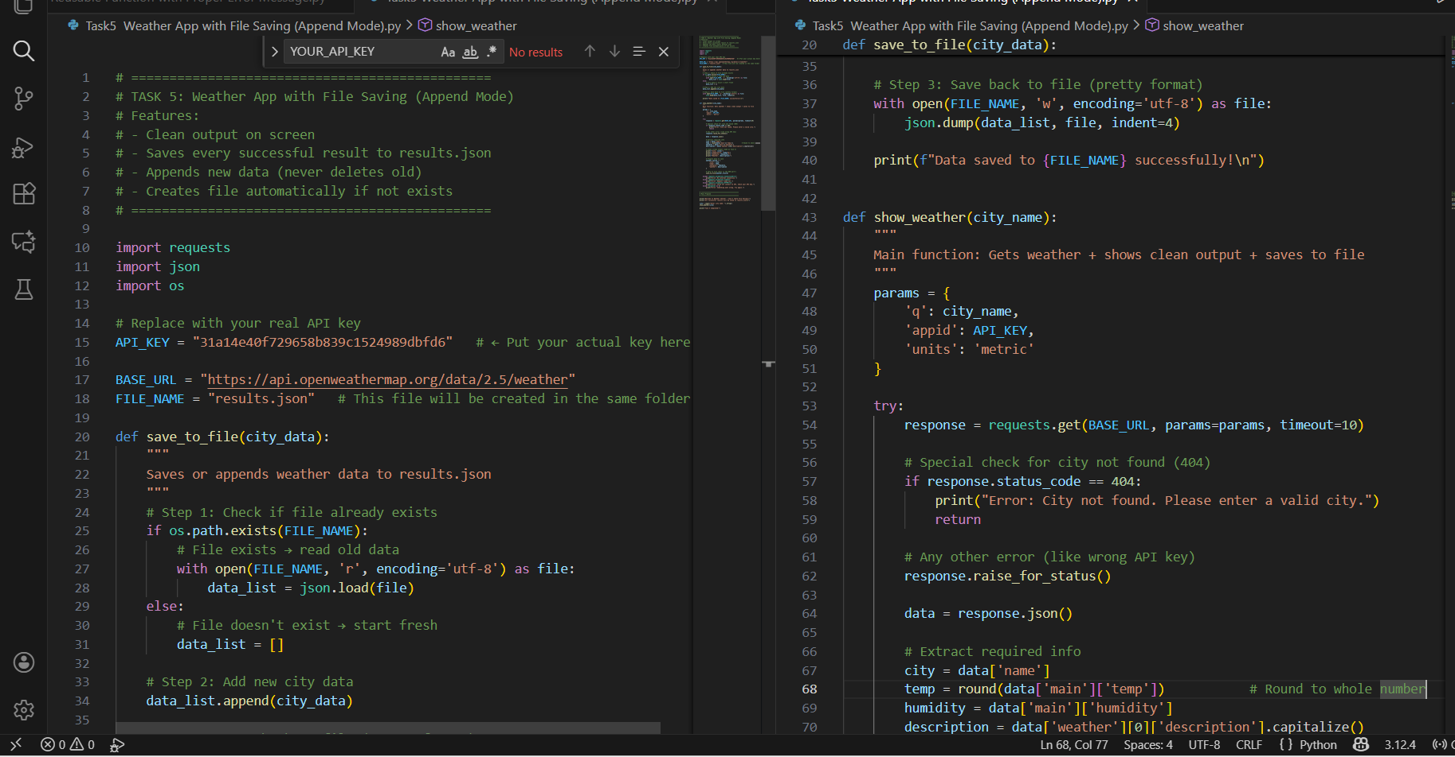  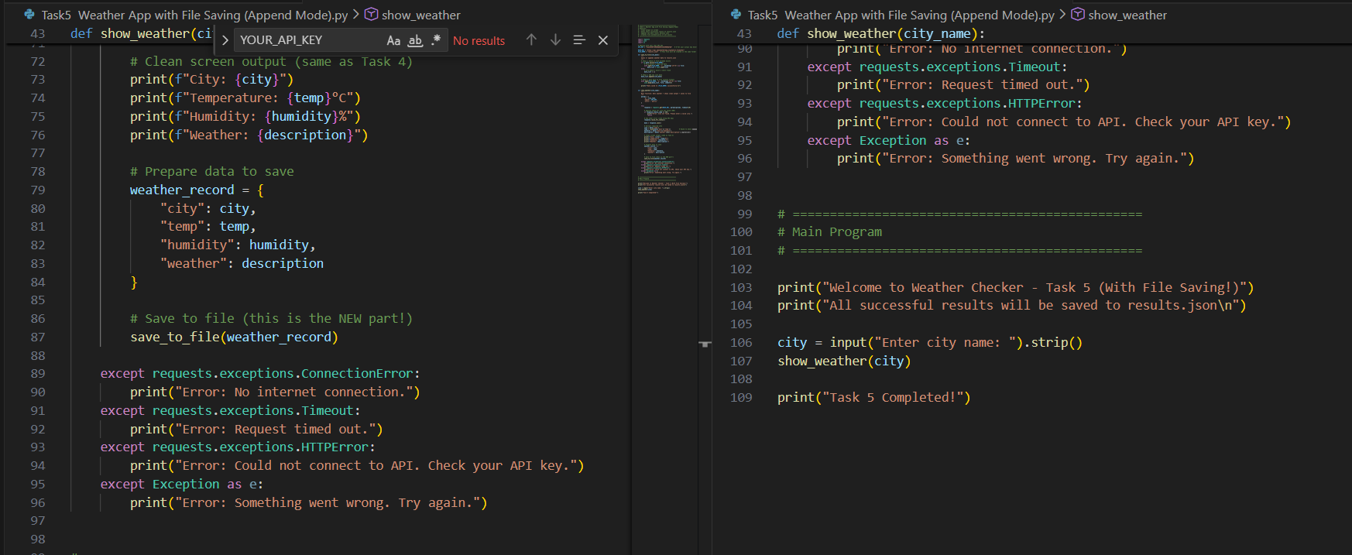  - Expected Output:  - Console still shows formatted output.  - A local file results.json is created/updated with stored responses like:  - [  - {"city": "London", "temp": 18, "humidity": 60, "weather": "Clear sky"},  - {"city": "New York", "temp": 22, "humidity": 55, "weather": "Few clouds"}  ]  Prompt: write a python function that display weather details of a city using weather api with error handling. Display weather details as JSON output. Store the weather details in current directory as text file, every run output will append  ✅ Deliverables (For All Tasks)  - AI-generated prompts for code and test case generation.  - At least 3 assert test cases for each task.  - AI-generated initial code and execution screenshots.  - Analysis of whether code passes all tests.  - Improved final version with inline comments and explanation.  - Compiled report (Word/PDF) with prompts, test cases, assertions, code, and output.  - 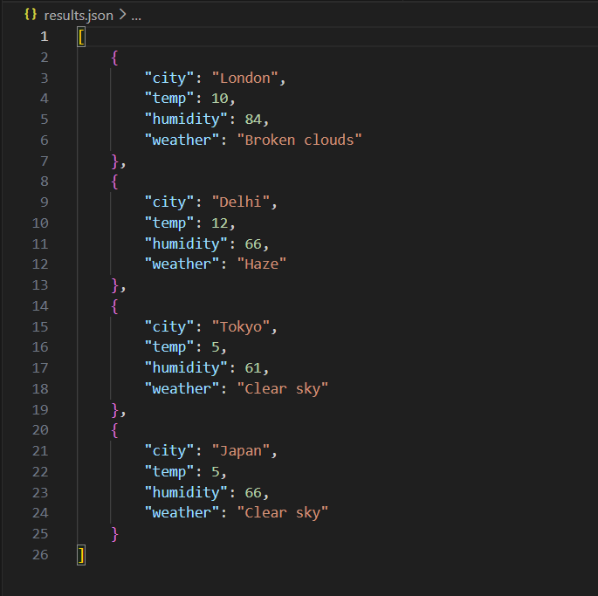  Store API Results Locally (Completed) Objective: Extend Task 4 to save every successful weather result into a local results.json file that grows with each new request (append mode).  Steps I Performed:  - Used the fully working code from Task 4 as the base  - Created a helper function save_to_file() to handle saving  - Used os.path.exists() to check if results.json already exists  - If file exists → loaded existing data using json.load()  - If file doesn’t exist → started with an empty list  - Appended new weather record (city, temp, humidity, weather) to the list  - Saved the complete updated list back to results.json using json.dump() with indent=4  - Rounded temperature to whole number for cleaner saved data  - Confirmed screen still shows clean output (same as Task 4)  - Successfully tested multiple runs:  - First run → created results.json  - Subsequent runs → appended new cities without deleting old data  - Invalid city → no data saved (only error shown)  Result:  - Console shows clean formatted output  - results.json file is automatically created and updated  - Every successful query is permanently stored and appended  - File format exactly matches expected JSON list structure |  |  |  |  |  | Week5 - Tuesday

